Arthur Shevtsov 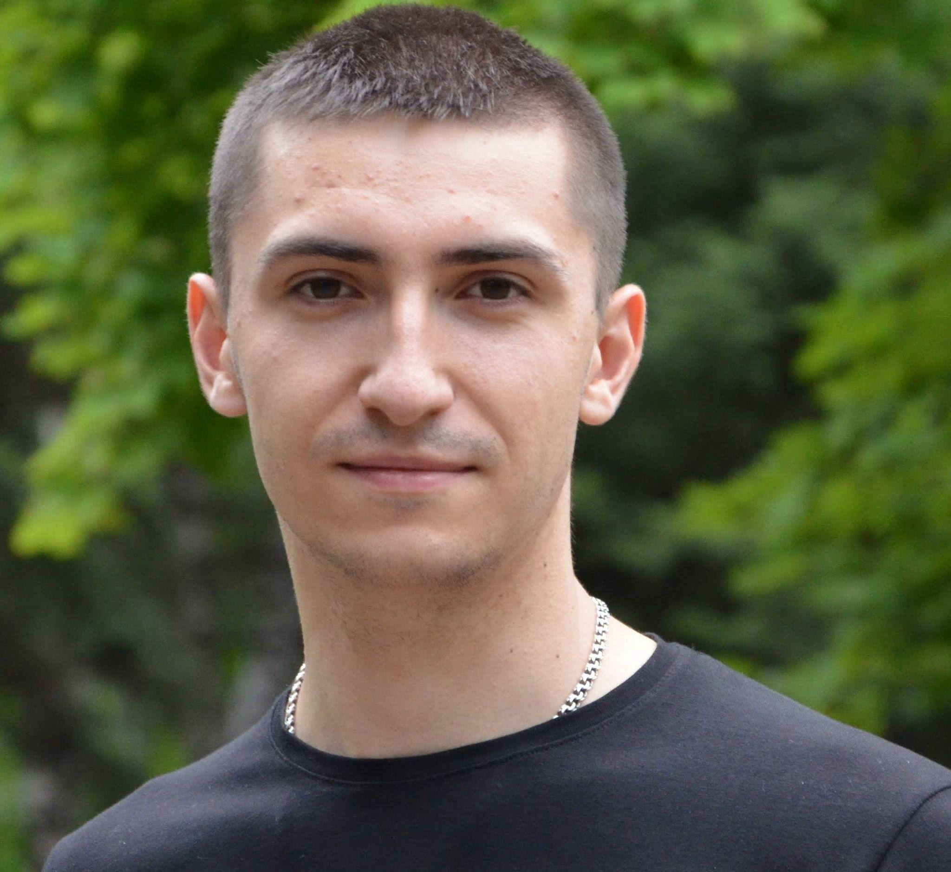

*Front-End Developer*

About me:

Region: Kharkiv, Ukraine

Phone: +380661969163

E-mail: [Lumenatom@gmail.com](mailto:Lumenatom@gmail.com)

Portfolio (projects): <https://lumenatom.github.io/Portfolio_resume/>

GitHub: <https://github.com/Lumenatom>

Skype: Arthur Shevtsov (live:.cid.937f855f62461dda)

Skills: *Html, Css (sass, flex, grid ), JavaScript, ReactJS*.

Language: English - basic, Ukrainian - high level, Russian - high level.

Courses: Фрилансер по жизни (Html, Css, JS), Василий Муравьев (JS, ReactJS), it-kamasutra (JS, ReactJS), Александр Лущенко (Html, JS, ReactJS), Glo Academy (Html, Css, JS)...

Education:

Software Engineering ( Bachelor )

DITM MNTU: 2016 - 2018 years.

Finance, Banking and Insurance ( Master )

DITM MNTU: 2018 - 2020 years.

Non-commercial experience:

*Sales Expert ( store - TTT )*

*Aug 2020 - until today*

*Shop manager ( store - TECHNOSTOK )*

*Dec 2017 - May 2020 (2 years 6 months)*

*Trade representative of TM "Zlagoda"*

*Jan 2017 - Dec 2017 (1 years)*